

Semester Two Examination, 2013

Question/Answer Booklet

MATHEMATICS 2A

Section One:

Calculator-free

Student’s name

Teacher’s name

Time allowed for this section
Reading time before commencing work: five minutes
Working time for this section: fifty minutes

Materials required/recommended for this section

To be provided by the supervisor
This Question/Answer Booklet
Formula Sheet

To be provided by the candidate
Standard items: pens, pencils, pencil sharpener, eraser, correction fluid/tape, ruler, highlighters

Special items: nil

Important note to candidates

No other items may be used in this section of the examination. It is your responsibility to ensure that you do not have any unauthorised notes or other items of a non-personal nature in the examination room. If you have any unauthorised material with you, hand it to the supervisor before reading any further.

Structure of this paper

Section | Number of questions available | Number of questions to be answered | Working time (minutes) | Marks available | Percentage of exam
Section One:  Calculator-free | 7 | 7 | 50 | 50 | 33
Section Two:  Calculator-assumed | 12 | 12 | 100 | 100 | 67
 |  |  | Total | 150 | 100

Instructions to candidates

- The rules for the conduct of Western Australian external examinations are detailed in the Year 12 Information Handbook 2013. Sitting this examination implies that you agree to abide by these rules.

- Write your answers in the spaces provided in this Question/Answer Booklet. Spare pages are included at the end of this booklet. They can be used for planning your responses and/or as additional space if required to continue an answer.
- Planning: If you use the spare pages for planning, indicate this clearly at the top of the page.
- Continuing an answer: If you need to use the space to continue an answer, indicate in the original answer space where the answer is continued, i.e. give the page number. Fill in the number of the question(s) that you are continuing to answer at the top of the page.

- Show all your working clearly. Your working should be in sufficient detail to allow your answers to be checked readily and for marks to be awarded for reasoning. Incorrect answers given without supporting reasoning cannot be allocated any marks. For any question or part question worth more than two marks, valid working or justification is required to receive full marks. If you repeat an answer to any question, ensure that you cancel the answer you do not wish to have marked.

- It is recommended that you do not use pencil, except in diagrams.

Section One: Calculator-free (50 Marks)
This section has seven (7) questions. Answer all questions. Write your answers in the spaces provided.

Working time for this section is 50 minutes.

Question 1 (6 marks)
(a) Evaluate

(i) 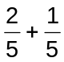 (1 mark)

(ii) 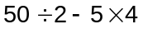 (1 mark)

(iii) 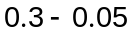 (1 mark)

(iv) 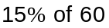 (1 mark)

(b) Convert the number 0.000 002 25 into scientific notation. (1 mark)

(c) Write 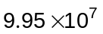 as an everyday number, not in scientific notation. (1 mark)

Question 2 (7 marks)
Four L-shapes have been drawn on the grid below, in positions numbered (i), (ii), (iii) and (iv).
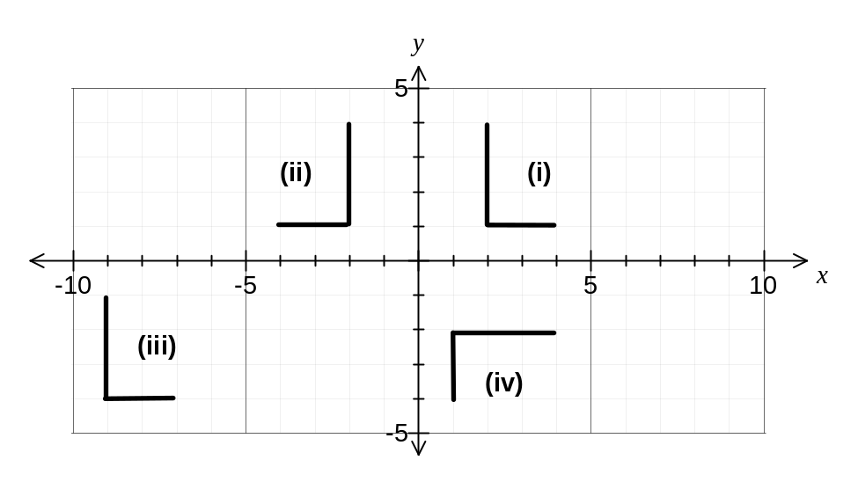
(a) Describe how to transform the L-shape from position (i) to position (ii). (2 marks)

(b) Describe how to transform the L-shape from position (i) to position (iii). (2 marks)

(c) Describe how to transform the L-shape from position (i) to position (iv). (2 marks)

(d) Add one or more straight lines to the shape below so that it exhibits symmetry. (1 mark)

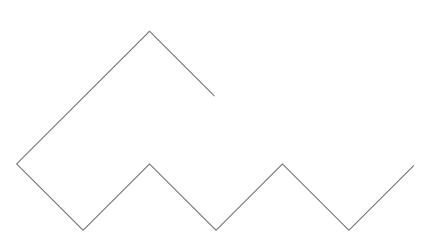

Question 3 (8 marks)
(a) Factorise 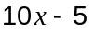. (1 mark)

(b) Simplify 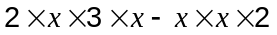. (1 mark)

(c) Expand and simplify 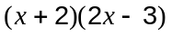. (2 marks)

(d) Solve 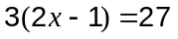. (2 marks)

(e) Solve 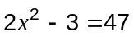. (2 marks)

Question 4 (9 marks)
(a) The values of and in the table below are related by a rule in the form 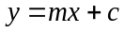.

 | 2 | 3 | 4 | 5
 | 15 | 12 | 9 | 6

Determine the values of and . (2 marks)

(b) The values of and in the graph below are related by a rule in the form 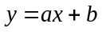.
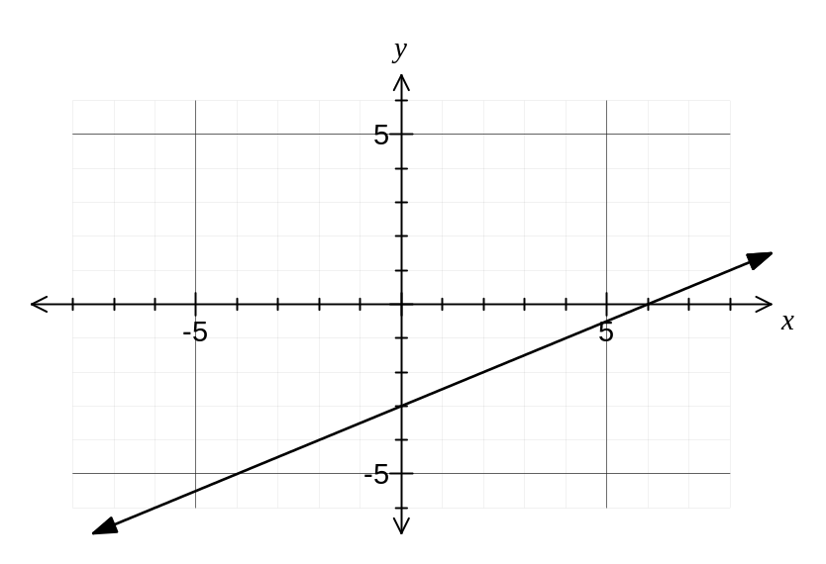

(i) Determine the values of and . (2 marks)

(ii) What is the gradient of the line on the graph above? (1 mark)

(c) The graph below shows the three lines 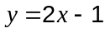, 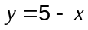 and 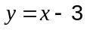.
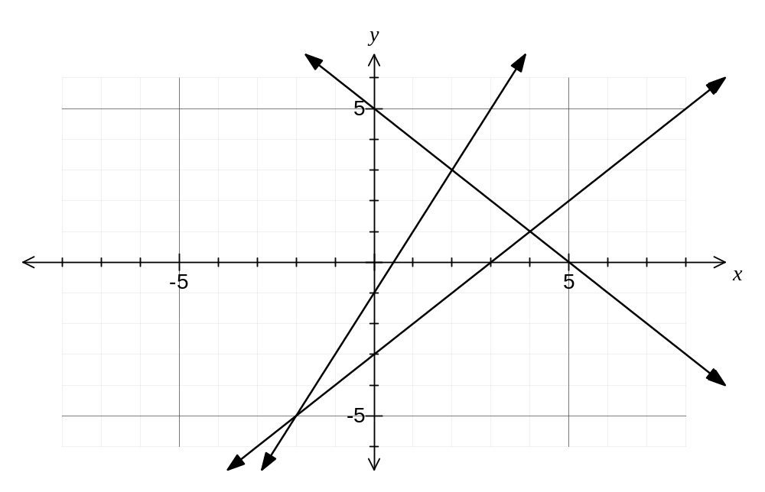

Using the graph, or otherwise, solve the following simultaneous equations:

(i) and . (2 marks)

(ii) 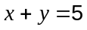 and 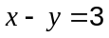. (2 marks)

Question 5 (9 marks)
The network diagram below shows the cost (in hundreds of dollars) to transport high-security items directly from one depot of a freight company to an adjacent depot.

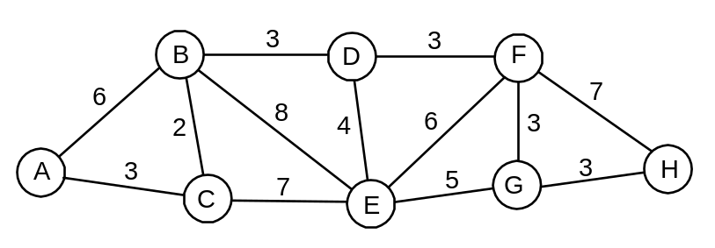

(a) How many depots are shown on the diagram? (1 mark)

(b) Between which two adjacent depots is the transport cost the highest and what is the cost?
(2 marks)

(c) How many odd vertices does the network have? (1 mark)

(d) Use your answer to (c) to explain whether the network is traversable. (2 marks)

(e) Determine the minimum cost of transporting a high-security item through this network from A to H, listing the route the item must take. (3 marks)

Question 6 (6 marks)
(a) Four different functions have equations 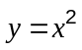, 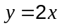, 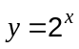 and 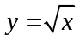.

Write down the equation of the linear function and explain your choice. (2 marks)

(b) In the table below, the variables and are related by an exponential function.
 | 0 | 1 | 2 | 3
 | 2 | 6 | 18 | 54

Explain how to recognise the exponential relationship from the numbers in the table.
(2 marks)

(c) The volume of water in a large bucket, , is measured every second, , as the bucket is held under a running tap. State whether a linear or an exponential function would best describe the relationship between and . Explain your answer. (2 marks)

Question 7 (5 marks)

A charity shop sold fund-raising T-shirts in six different colours, as shown in the pie chart below.

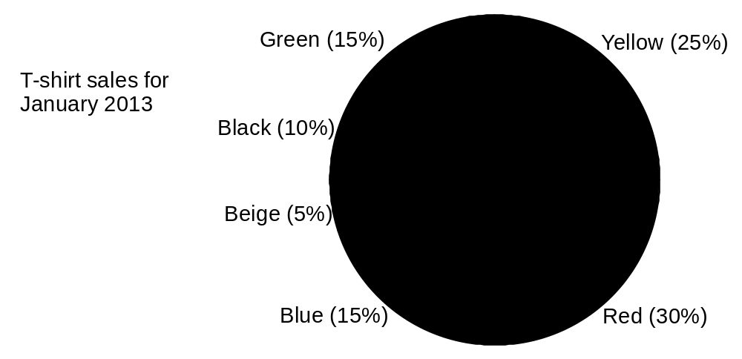

(a) Which colour T-shirt was most popular? (1 mark)

(b) How many times more popular was the yellow T-shirt compared to the beige? (1 mark)

The charity shop sold 45 red T-shirts in January 2013.

(c) How many black T-shirts did they sell in January 2013? (1 mark)

(d) How many T-shirts did the charity shop sell altogether in January 2013? (2 marks)

Additional working space

Question number: _________

This examination paper may be freely copied, or communicated on an intranet, for non-commercial purposes within educational institutes that have purchased the paper from WA Examination Papers provided that WA Examination Papers is acknowledged as the copyright owner. Teachers within purchasing schools may change the paper provided that WA Examination Paper's moral rights are not infringed.

Copying or communication for any other purposes can only be done within the terms of the Copyright Act or with prior written permission of WA Examination papers.

Published by WA Examination Papers
PO Box 445 Claremont WA 6910

